
Holy Cross College

Semester 2 Examination 2012

Question/Answer Booklet

Year 10 Science
Please place your student identification label in this box
(General)

Student Name
Student’s Teacher

Time allowed for this paper

Reading time before commencing work: 10 minutes
Working time for paper: 100 minutes

Materials required/recommended for this paper

To be provided by the supervisor

This Question/Answer Booklet
Data Sheet

To be provided by the candidate

Standard items: pens, pencils, eraser, correction fluid, ruler, highlighters.
Special items: non-programmable calculators satisfying the conditions set by the School Curriculum and Standards Authority for this course.

Important note to candidates

No other items may be taken into the examination room. It is your responsibility to ensure that you do not have any unauthorised notes or other items of a non-personal nature in the examination room. If you have any unauthorised material with you, hand it to the supervisor before reading any further.

Structure of this paper

Section | Number of questions available | Number of questions to be answered | Suggested working time  (minutes) | Marks available | Percentage of exam
Section One:  Multiple Choice | 60 | 60 | 40 | 60 | 35
Section Two:  Short Answer | 19 | 19 | 45 | 94 | 55
Section Three:  Comprehension | 9 | 9 | 15 | 17 | 10
 |  |  |  | 171 | 100

Instructions to candidates

1. The rules for the conduct of examinations at Holy Cross College are detailed in the College
Examination Policy. Sitting this examination implies that you agree to abide by these rules.

2. Write your answers in this Question/Answer Booklet.

3. Working or reasoning should be clearly shown when calculating or estimating answers.

4. You must be careful to confine your responses to the specific questions asked and to follow
any instructions that are specific to a particular question.

5. Spare pages are included at the end of this booklet. They can be used for planning your
responses and/or as additional space if required to continue an answer.

• Planning: If you use the spare pages for planning, indicate this clearly at the top of the
page.
• Continuing an answer: If you need to use the space to continue an answer, indicate in
the original answer space where the answer is continued, i.e. give the page number.
Fill in the number of the question(s) that you are continuing to answer at the top of the
page.

Achievement Standards

The atomic structure and properties of elements are used to organise them in the Periodic Table.

Different types of chemical reactions are used to produce a range of products and can occur at different rates.

The motion of objects can be described and predicted using the laws of physics.
SECTION 1 MULTIPLE CHOICE (60 marks)

Choose the best answer for each question in the Multiple Choice Question booklet.

Mark your selection with a cross.

1 | (a) | (b) | (c) | (d) |  | 31 | (a) | (b) | (c) | (d)
2 | (a) | (b) | (c) | (d) |  | 32 | (a) | (b) | (c) | (d)
3 | (a) | (b) | (c) | (d) |  | 33 | (a) | (b) | (c) | (d)
4 | (a) | (b) | (c) | (d) |  | 34 | (a) | (b) | (c) | (d)
5 | (a) | (b) | (c) | (d) |  | 35 | (a) | (b) | (c) | (d)
6 | (a) | (b) | (c) | (d) |  | 36 | (a) | (b) | (c) | (d)
7 | (a) | (b) | (c) | (d) |  | 37 | (a) | (b) | (c) | (d)
8 | (a) | (b) | (c) | (d) |  | 38 | (a) | (b) | (c) | (d)
9 | (a) | (b) | (c) | (d) |  | 39 | (a) | (b) | (c) | (d)
10 | (a) | (b) | (c) | (d) |  | 40 | (a) | (b) | (c) | (d)
11 | (a) | (b) | (c) | (d) |  | 41 | (a) | (b) | (c) | (d)
12 | (a) | (b) | (c) | (d) |  | 42 | (a) | (b) | (c) | (d)
13 | (a) | (b) | (c) | (d) |  | 43 | (a) | (b) | (c) | (d)
14 | (a) | (b) | (c) | (d) |  | 44 | (a) | (b) | (c) | (d)
15 | (a) | (b) | (c) | (d) |  | 45 | (a) | (b) | (c) | (d)
16 | (a) | (b) | (c) | (d) |  | 46 | (a) | (b) | (c) | (d)
17 | (a) | (b) | (c) | (d) |  | 47 | (a) | (b) | (c) | (d)
18 | (a) | (b) | (c) | (d) |  | 48 | (a) | (b) | (c) | (d)
19 | (a) | (b) | (c) | (d) |  | 49 | (a) | (b) | (c) | (d)
20 | (a) | (b) | (c) | (d) |  | 50 | (a) | (b) | (c) | (d)
21 | (a) | (b) | (c) | (d) |  | 51 | (a) | (b) | (c) | (d)
22 | (a) | (b) | (c) | (d) |  | 52 | (a) | (b) | (c) | (d)
23 | (a) | (b) | (c) | (d) |  | 53 | (a) | (b) | (c) | (d)
24 | (a) | (b) | (c) | (d) |  | 54 | (a) | (b) | (c) | (d)
25 | (a) | (b) | (c) | (d) |  | 55 | (a) | (b) | (c) | (d)
26 | (a) | (b) | (c) | (d) |  | 56 | (a) | (b) | (c) | (d)
27 | (a) | (b) | (c) | (d) |  | 57 | (a) | (b) | (c) | (d)
28 | (a) | (b) | (c) | (d) |  | 58 | (a) | (b) | (c) | (d)
29 | (a) | (b) | (c) | (d) |  | 59 | (a) | (b) | (c) | (d)
30 | (a) | (b) | (c) | (d) |  | 60 | (a) | (b) | (c) | (d)

SECTION 2 SHORT ANSWER (94 marks)

Attempt all questions. Write your answers in the spaces provided.

1. Classify the following elements as alkali metals, transition metals, metalloid (semi-metals),
halogens or noble (inert) gases. Use the periodic table on the data sheet provided.

K Ge He Cu Fr Cl Ag Ar

Alkali Metal | Transition Metal | Metalloid  (Semi-Metal) | Halogen | Noble (Inert) Gas

(4 marks)

2. Complete the following table showing the constituent particles of each element.

ELEMENT | PROTONS | NEUTRONS | ELECTRONS
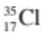
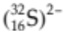
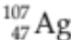

(4 marks)

3. An aluminium atom (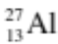) has the ability to form the Al³⁺ ion. It can then form ionic
compounds with other ions such as Cl¹⁻.

(a) Draw a diagram to show the electron configuration in the aluminium atom.

(2 marks)

(b) Explain what happens in order for the aluminium atom to become the aluminium ion
Al³⁺.

(2 marks)

(c) Why is the Al³⁺ ion so stable?

(2 marks)

(d) Explain how the "ionic bond" arises between the Al³⁺ ion and the Cl¹⁻ ion.

(2 marks)

4. Write the chemical formula for each of the following compounds.

NAME | FORMULA
potassium nitrate
magnesium phosphate
aluminium sulphate
phosphorus tribromide
iron (III) iodide
barium acetate
disulphur tetraiodide

(7 marks)

5. Balance the following equations.

(a) Al₂(CO₃)₃ + HCl  AlCl₃ + H₂O + CO₂

(b) C₃H₈ + O₂  CO₂ + H₂O

(c) NaOH + Fe(NO₃)₂  Fe(OH)₂ + NaNO₃

(6 marks)

6. Write fully balanced equations for the following.

(a) calcium carbonate + phosphoric acid (H₃PO₄)  calcium phosphate + water +
carbon dioxide

(b) hexane (C₆H₁₄) + oxygen  carbon dioxide + water

(4 marks)
7. Write balanced equations for the following acid reactions.
(Hint: Complete the word equations first.)

(a) zinc carbonate + nitric acid

(b) potassium hydroxide + sulphuric acid

(6 marks)

8. Use the table of solubilities to determine whether a reaction occurs when the following
solutions are mixed. Where a reaction occurs, write a balanced equation. Write "no
reaction" if appropriate.

(Hint: It might be best to complete the word equation first to make it easier to write a
balanced equation.)

(a) Aluminium nitrate solution + sodium hydroxide solution.

(b) Barium nitrate solution + potassium sulphate solution.

(4 marks)

9. Some students investigated the movement of a dynamics trolley across a bench using a ticker
timer to record the motion. The timer puts 50 dots per second (1 dot-spacing = 0.02 sec) onto
the tape, and the tape is shown below.

. . . . . . . . . . . . . . . . . . . .

(a) Using any 6 dots of your choosing, perform a calculation of the average speed. Show
all of your working below.

(3 marks)

(b) What is the difference between a ticker tape for constant velocity and acceleration?
Draw a representation of each tape below.

(i) Constant Velocity

(ii) Acceleration

(2 marks)

10. Vincent dropped a stone down a well and saw it hit the bottom 3.5 s later. Calculate the
velocity of the stone at impact, given the acceleration due to gravity is 9.80 ms⁻².

(3 marks)
11. Sean steps on the brake pedal of his car for 2.5 s. This applies a regarding force of 2100 N to
slow his 750 kg car, which is travelling in an easterly direction. Calculate his car's
deceleration.

(3 marks)
12. Convert the following.

(a) 86.3 hours = s (b) 26700 mm = m

(c) 345 kmh⁻¹ = ms⁻¹ (3 marks)

13. Max has a mass of 57 kg on Earth. He is lucky enough to be selected for a junior astronaut
programme and journeys to the International Space Station (ISS) for a 3-month stay.

(a) Calculate Max's weight on Earth.

(3 marks)

(b) Max "floats” in space within the ISS. Is he weightless? Explain your answer.

(2 marks)
(c) Is Max ever weightless in space? Explain your answer.

(2 marks)

14. A plane takes off from a country airstrip and flies 250 km West, then 500 km South. It lands
on a farm owned by the pilot. The total time of flight is 1.5 hours.

(a) Draw a vector diagram (not to scale) to show the addition of the vectors and the
resultant vector.

(2 marks)

(b) Calculate the displacement of the plane from its starting point.

(3 marks)

(c) Calculate the average speed of the plane for the journey. Perform the calculation in
kmh⁻¹.

(3 marks)

15. A force of 36 N acts on a mass of 24 kg. What is the acceleration of the mass?

(3 marks)

16. A mass of 28 kg is brought to rest by an average force of 98 N in 13 s. What is the initial
velocity of the mass?

(4 marks)

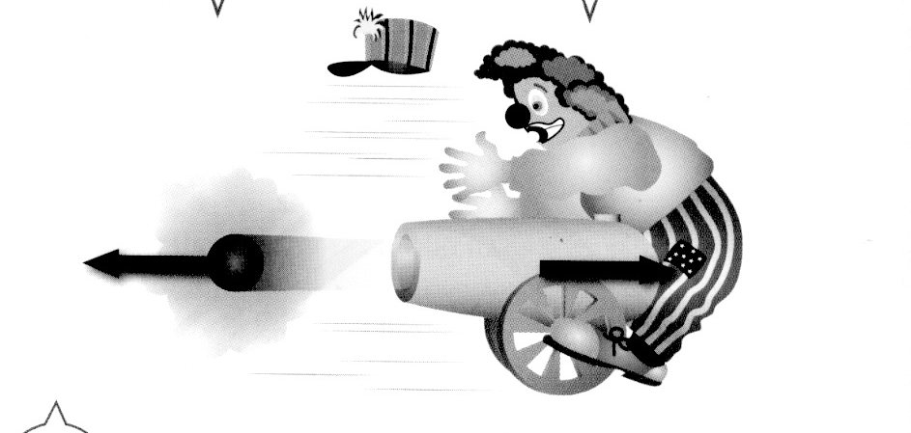
17. Look at the diagram showing a clown and a cannon at
a circus. Analyse it and explain why the cannon hits
the clown, using Newton's Laws in your explanation.

(2 marks)
18. What is the acceleration of the car shown in the diagram below?

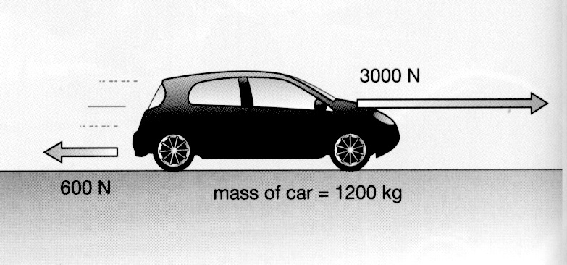

(4 marks)
19. The graph below shows the motion of a bicycle over a 20.0 s period.
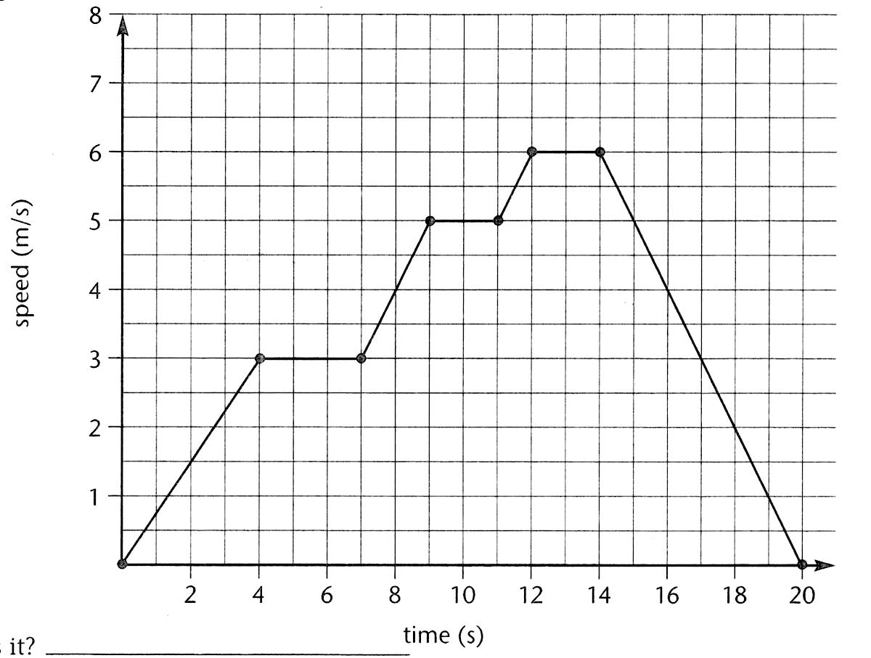

(a) During which time intervals was the bicycle travelling at a constant velocity?

(2 marks)

(b) Calculate the deceleration of the bike as it came to a stop.

(3 marks)

(c) From the graph, determine the displacement of the bike over the first 11.0 s of
movement.

(4 marks)
SECTION 3 COMPREHENSION (17 marks)

Read the article and then answer the questions that follow. Write your answers in the spaces provided.

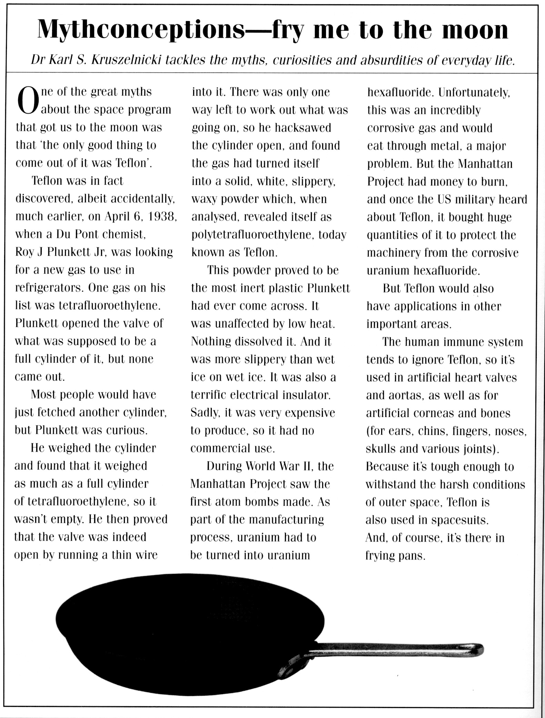
1. When was Teflon discovered and by whom?

(2 marks)

2. What is the correct chemical name of Teflon?

(1 mark)
3. Describe what Teflon looks like.

(2 marks)

4. What properties make Teflon an extremely useful material?

(2 marks)

5. Teflon is said to be inert - what does this mean?

(1 mark)

6. What research was the inventor doing when he discovered Teflon?

(1 mark)

7. What stopped Teflon from being commercially produced in the early days?

(1 mark)

8. Is Teflon a metal or a plastic? Give one piece of evidence.

(1 mark)
9. Complete the following table about the uses of Teflon.

LOCATION | USE | PROPERTY RELATED TO USES
Body
Space
Kitchen

(6 marks)

END OF EXAMINATION

THIS PAGE HAS BEEN DELIBERATELY LEFT BLANK.
THIS PAGE HAS BEEN DELIBERATELY LEFT BLANK.
THIS PAGE HAS BEEN DELIBERATELY LEFT BLANK.

